Week 7 Hands-on: Angular

Exercise 1: Scaffold and Explore the Angular Project
Description: Scaffolded a new Angular workspace using the Angular CLI (ng new student-course-portal). Created core components for the application including header, home, course-list, and student-profile. Assembled the base layout in app.component.html using the <app-header> selector and <router-outlet>.
Source Code:
src/app/components/header/header.component.html
HTML
<nav>
<h2>Student Course Portal</h2>
<ul>
<li><a routerLink="/">Home</a></li>
<li><a routerLink="/courses">Courses</a></li>
<li><a routerLink="/profile">Profile</a></li>
</ul>
</nav>
src/app/pages/home/home.component.html
HTML
<div class="container">
<h1>Welcome to the Student Course Portal</h1>
<p>Manage your enrollments, view your grades, and discover new courses to advance your education.</p>
<div class="stats">
<div class="stat-box"><h3>12</h3><p>Courses Available</p></div>
<div class="stat-box"><h3>3</h3><p>Enrolled</p></div>
<div class="stat-box"><h3>3.8</h3><p>GPA</p></div>
</div>
</div>
Output: 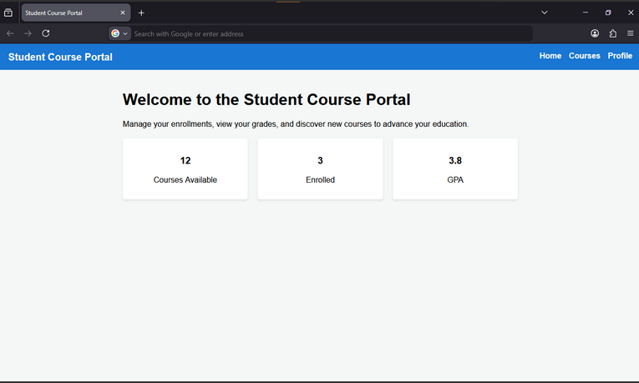

Exercise 2: Data Binding, Lifecycle Hooks & Component Communication
Description: Implemented Angular's four binding types (interpolation, property binding, event binding, and two-way [(ngModel)] binding). Set up parent-child component communication where course-list passes data down to course-card via @Input() and listens for an enrollRequested event bubbling up via @Output() and EventEmitter.
Source Code:
src/app/pages/home/home.component.ts
TypeScript
import { Component, OnInit, OnDestroy } from '@angular/core';

@Component({
selector: 'app-home',
templateUrl: './home.component.html'
})
export class HomeComponent implements OnInit, OnDestroy {
portalName: string = 'Student Course Portal';
isPortalActive: boolean = true;
searchTerm: string = '';
message: string = '';

ngOnInit() {
console.log('HomeComponent initialised — courses loaded');
}

ngOnDestroy() {
console.log('HomeComponent destroyed');
}

onEnrollClick() {
this.message = 'Enrollment opened!';
}
}
src/app/components/course-card/course-card.component.ts
TypeScript
import { Component, Input, Output, EventEmitter, OnChanges, SimpleChanges } from '@angular/core';

@Component({
selector: 'app-course-card',
templateUrl: './course-card.component.html'
})
export class CourseCardComponent implements OnChanges {
@Input() course!: { id: number, name: string, code: string, credits: number };
@Output() enrollRequested = new EventEmitter<number>();

ngOnChanges(changes: SimpleChanges) {
console.log('Course changed:', changes['course'].previousValue, '->', changes['course'].currentValue);
}
}
Output: 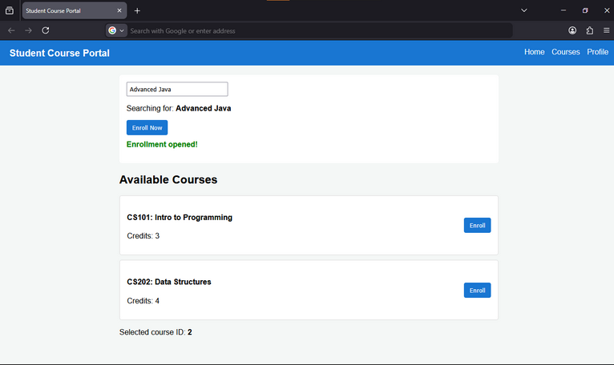

Exercise 3: Directives & Pipes — Built-in and Custom
Description: Used structural directives (*ngIf, *ngFor with trackBy, *ngSwitch) to control DOM rendering based on state. Applied attribute directives ([ngClass], [ngStyle]) to dynamically alter border colors and layouts based on a course's gradeStatus. Finally, built a custom appHighlight directive for hover effects and a creditLabel custom pipe for formatting text.
Source Code:
src/app/components/course-card/course-card.component.html
HTML
<div class="course-card"
[ngClass]="{'expanded': isExpanded, 'card--full': course.credits >= 4}"
[ngStyle]="{'border-left-color': getBorderColor()}"
appHighlight="lightyellow">

<div class="card-header">
<h4>{{ course.code }}: {{ course.name }}</h4>
<ng-container [ngSwitch]="course.gradeStatus">
<span *ngSwitchCase="'passed'" class="badge badge-passed">Passed</span>
<span *ngSwitchCase="'failed'" class="badge badge-failed">Failed</span>
<span *ngSwitchDefault class="badge badge-pending">Pending</span>
</ng-container>
</div>

<p>Credits: <strong>{{ course.credits | creditLabel }}</strong></p>
<button (click)="isExpanded = !isExpanded">
{{ isExpanded ? 'Hide Details' : 'Show Details' }}
</button>
</div>
src/app/pipes/credit-label.pipe.ts
TypeScript
import { Pipe, PipeTransform } from '@angular/core';

@Pipe({
name: 'creditLabel'
})
export class CreditLabelPipe implements PipeTransform {
transform(value: number | null): string {
if (!value || value === 0) return 'No Credits';
return value === 1 ? '1 Credit' : `${value} Credits`;
}
}
Output: 